**Status Report**

**Team 11**

**Work done during last week**

**Achievements**

* Sprint 3 planning is reevaluated as per advice from the review meeting.
* Few changes are made by the team and buffer time is allotted to these extra meeting for replan process.
* We have defined an user point is equal to 3 hour’s effort.
* The user stories considered for sprint 3 are based on the sprint velocity given by the project management tool taiga.io, which is of 98 user points. User stories which are assigned to sprint 3 are equivalent of 98 user points .
* As per now the completed user stories are offers, social connectivity and privacy policy.
* The user stories which are in developing state are search, product quantity and subscription.
* The tracking of work progress is done basically by burndown chart and also along with the logbook, where each member in the team logs the working time .
* The burndown chart consists of X-axis and Y-axis. The X-axis consists number of working days and Y-axis consists of Remaining effort (hours). It also provides the number of user stories completed in the sprint 3.

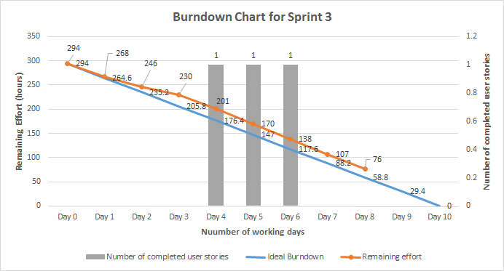

**Figure 1. Burndown chart for sprint 3**

**Issues**

* Few Scrum meetings are rescheduled due to unavailability.
* Due to holidays, expected outcomes are not achieved.
* We finished the sprint-3 only up to 38%, and there is a chance of using buffer time for further task accomplishment.

**Note:** Everyone in the team has participated and equally contributed towards the project. No one is working remotely away from BTH.